**R Code for Examples in the book**

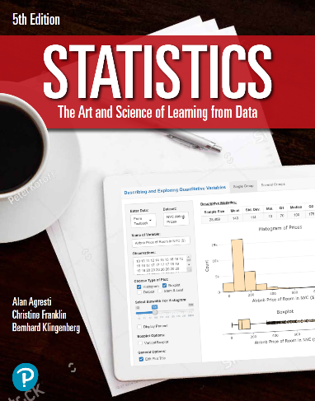

***“Statistics: The Art and Science of Learning from Data”***

**by Agresti, Franklin and Klingenberg, 5th edition**

**Chapter 12**

**Example 10: The Strength Study – The Squared Correlation Coefficient *r*2**

## Reading in data

athletes <- read.csv(file='https://raw.githubusercontent.com/artofstat/data/master/Chapter12/highschool_female_athletes.csv')  
attach(athletes) # so we can refer to variable names

## To obtain correlation between maxBP and BP60

r <- cor(maxBP..lbs., BP60)  
rSquared <- r ** 2  
rSquared

## [1] 0.6432443

## Alternatively, you can fit a regression and check the summary

linReg <- lm(maxBP..lbs. ~ BP60, data = athletes)  
summary(linReg)$r.squared

## [1] 0.6432443